# Ideation Phase

**Define the Problem Statements**

|  |  |
| --- | --- |
| Date | 17 October 2022 |
| Team ID | PNT2022TMID11899 |
| Project Name | Project - Inventory Management System for Retailers |
| Maximum Marks | 2 Marks |

**Customer Problem Statement Template:**

To create an inventory management system that will allow retailers to satisfy demand from customers without running out of inventory or holding too much on hand.

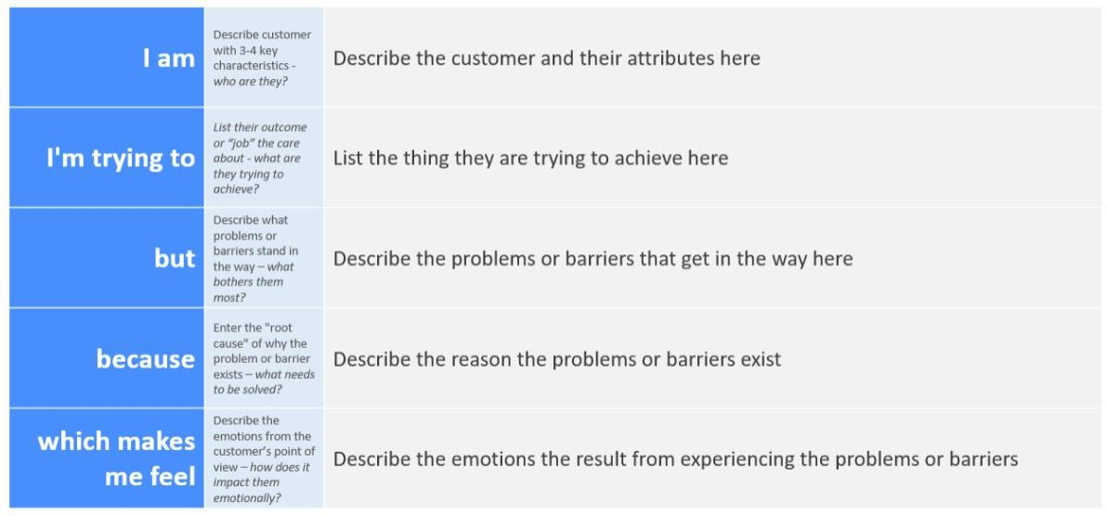

|  |  |  |  |  |  |
| --- | --- | --- | --- | --- | --- |
| **Problem Statement**  **(PS)** | **I am (Customer)** | **I’m trying to** | **But** | **Because** | **Which makes me**  **feel** |
| PS-1 | Retailer | Find number of stocks in my inventory | It’s difficult | My inventory has n number of product difficult to count manually | Tired |
| PS-2 | Retailer | Maintaining the invoice of inventory | It’s difficult and  unsecure | It may get lost or damaged | Afraid |
| PS-3 | Retailer | Access a particular stock | I can’t find the stock | There are n number of stock in my inventory | Time consuming |
| PS-4 | Retailer | Minimize stock error | I can’t minimize it | It’s tough to maintain large number of stocks without loss | disappointed |